Remaining Shelf-Life Estimation of Fresh Fruits and Vegetables During Transportation

Fruits and Vegetables will be fresh for some duration and while transportation its mandatory to predict shelf life of fruits and vegetables for on time delivery. Fresh Fruits and Vegetables (FFV) life often dependent on CO2 or temperature so the frequent we open refrigerator door the more CO2 or temperature will be injected and life will be reduced.

To accurately predict shelf life of FFV author of this paper generating FFV shelf life using simulation with and without opening doors and this simulation dataset can be downloaded from below URL

<https://data.mendeley.com/datasets/jb8bdstwwb/1>

Above dataset contains Time and temperature and by subtracting old temperature with current temperature we can get FFV RSL (remaining shelf life) value. ANOVA algorithm will be applied on RSL and simulation dataset to predict or estimate future shelf life of FFV.

Analysis of variance (ANOVA) is a statistical technique used to check if the means of two or more groups are significantly different from each other. ANOVA checks the impact of one or more factors by comparing the means of different samples.

To train above algorithms we are using below dataset values

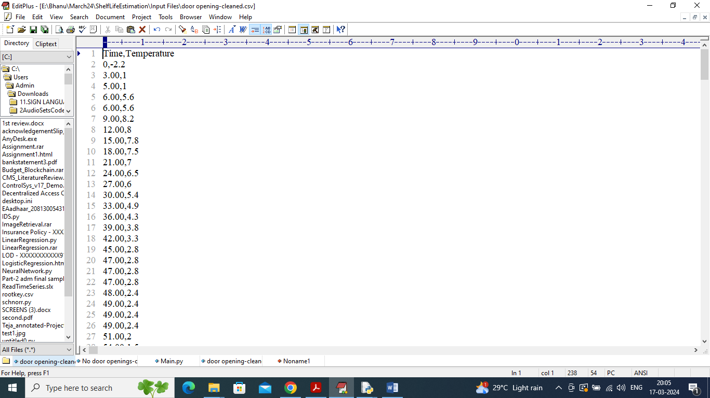

Above dataset is from ‘Door Opening’ simulation values which contains door opening time and temperature values. By using above temperature values we can employ ANOVA and SLEM to estimate future shelf life.

ANOVA and SLEM performance will be evaluated using Model error which refers to difference between Observed shelf life and predicted shelf life so the lower the error the better is the model

Extension Concept

In propose paper author employing traditional ANOVA algorithm to estimate shelf life so its error rate will be little high. To reduce error rate as extension we are employing CNN deep learning algorithm which will optimize training features using multiple neurons and help algorithm to get more optimized features which will reduce model prediction error.

SCREEN SHOTS

To run project double click on ‘run.bat’ file to get below screen

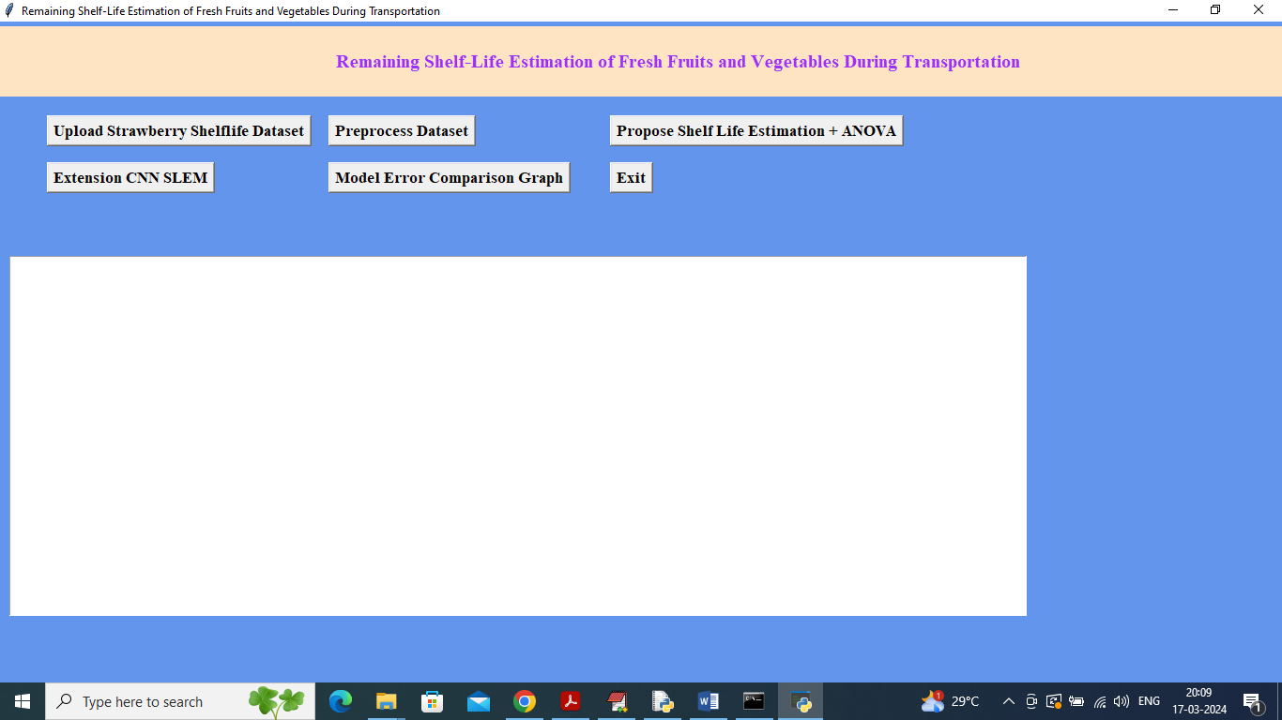

In above screen click on ‘Upload Strawberry Shelf life Dataset’ button to upload dataset and get below output

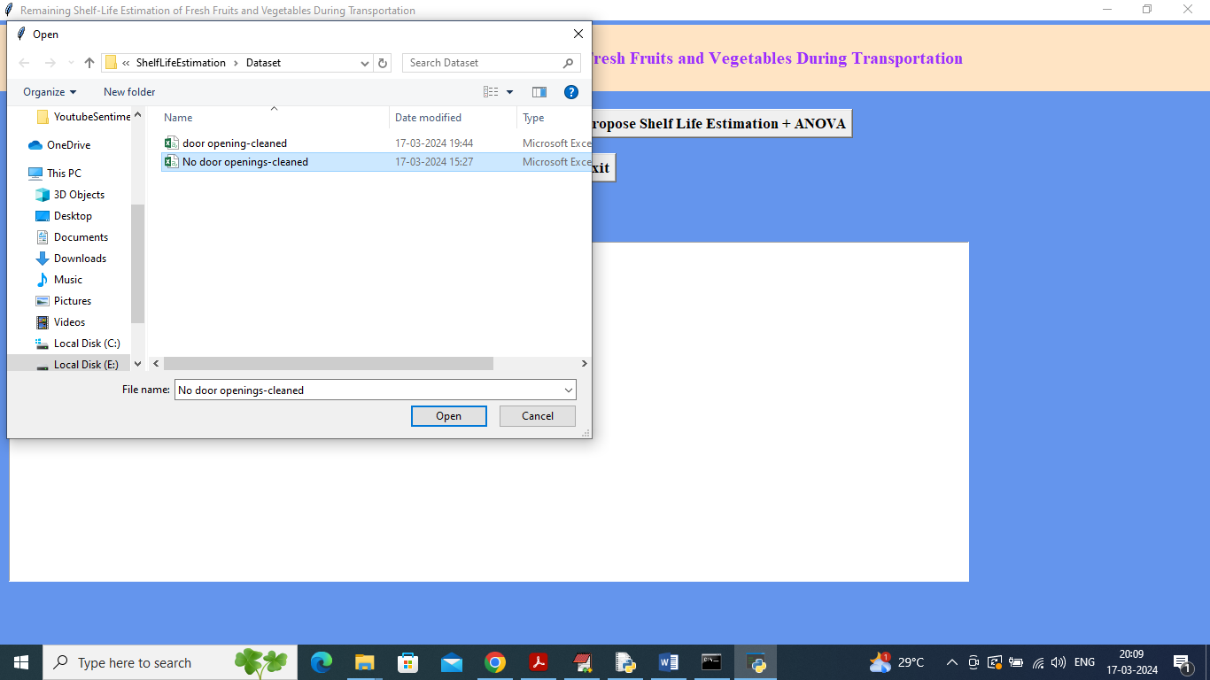

In above screen selecting and uploading ‘No door opening’ dataset and then click on ‘Open’ button to load dataset and get below page

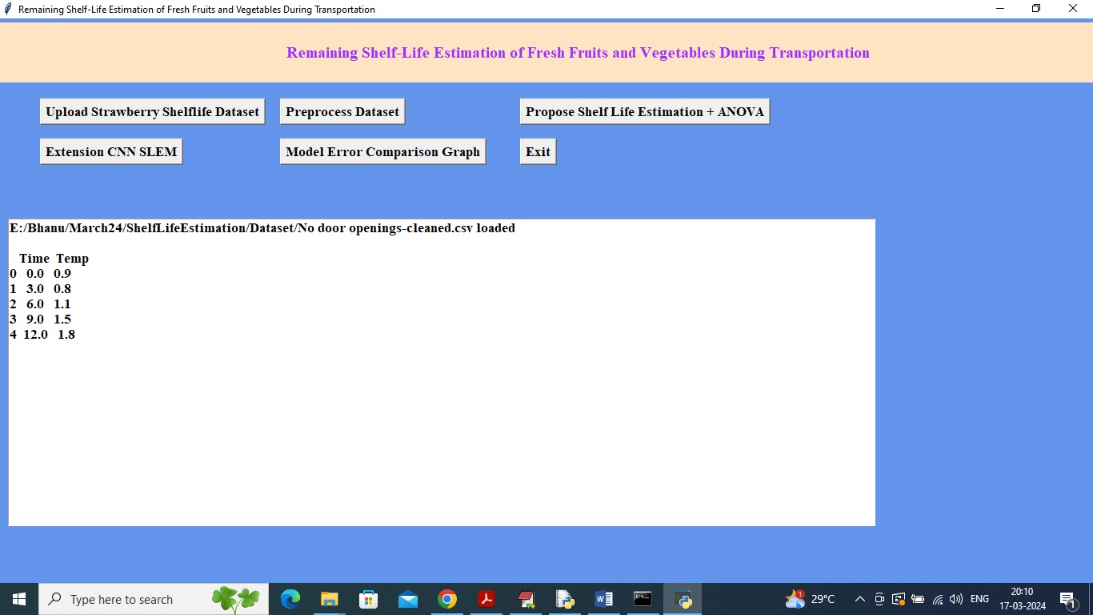

In above screen dataset loaded and displaying some values from dataset and now click on ‘Pre-process Dataset’ button to remove missing values and then calculate RSL for each temperature value and get below output

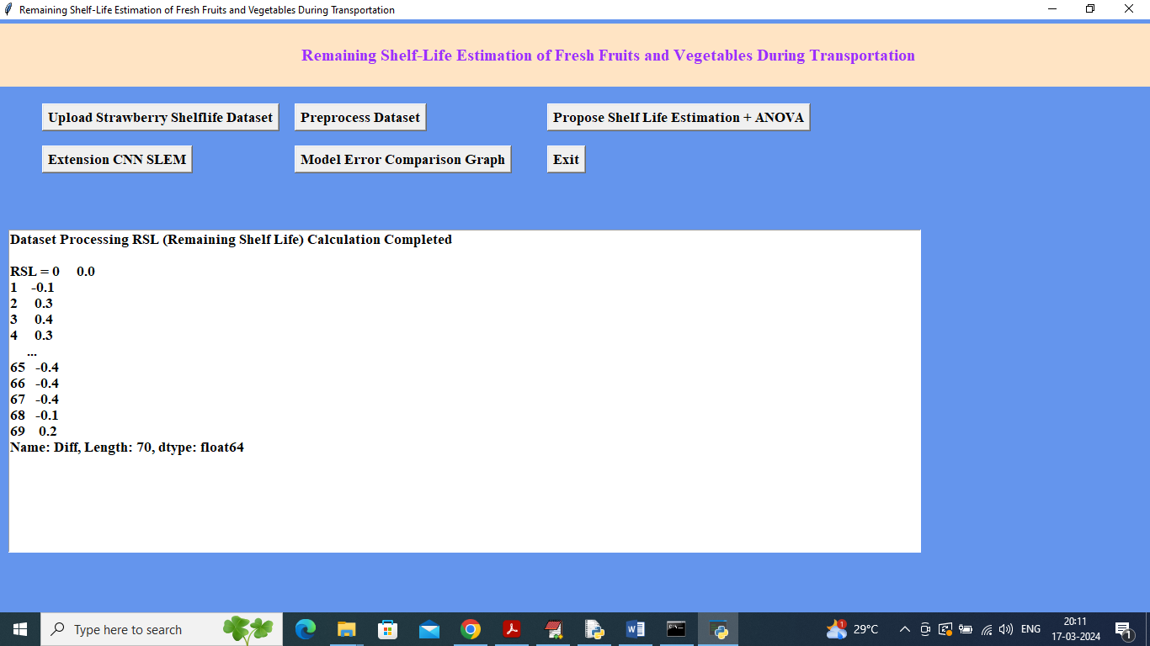

In above screen for each record calculated RSL value using previous and current temperature values and now click on ‘Propose Shelf Life Estimation + ANOVA’ button to train ANOVA and then predict future shelf life of fruits and vegetables

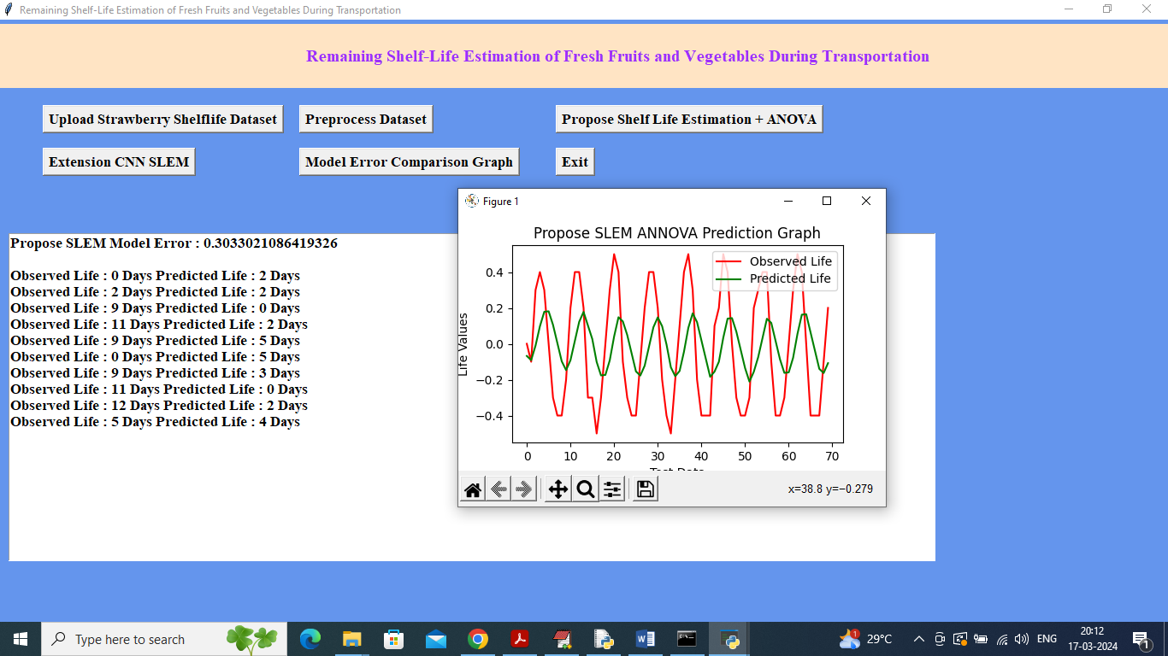

In above screen propose model got 30% error rate and in next lines can see Observed or original ‘shelf life’ and then can see predicted shelf life and can see close difference between original and predicted shelf life. In graph x-axis represents number of test data and y-axis represents shelf life where red line is for Original shelf life and green line is for predicted shelf life. In above graph can see both lines are overlapping with some gap so we can say prediction is little accurate. Now click on ‘Extension CNN SLEM’ button to train extension CNN algorithm and get below output

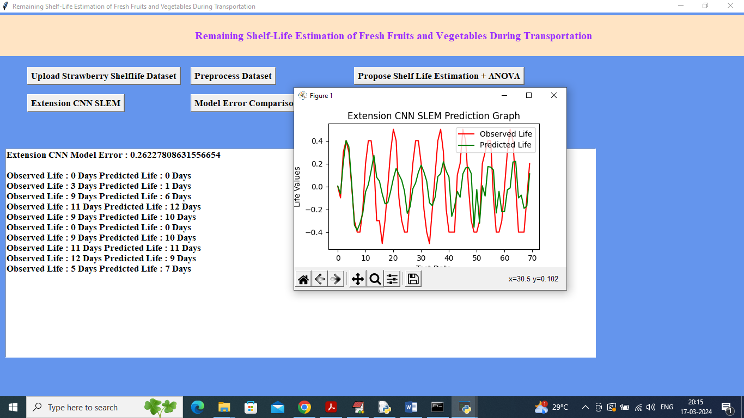

In above screen extension CNN model got 0.26% error which is lesser than propose algorithm and can see original and predicted shelf life and in graph also can see green and red line overlapping closely. Now click on ‘Model Error Comparison Graph’ button to get below comparison

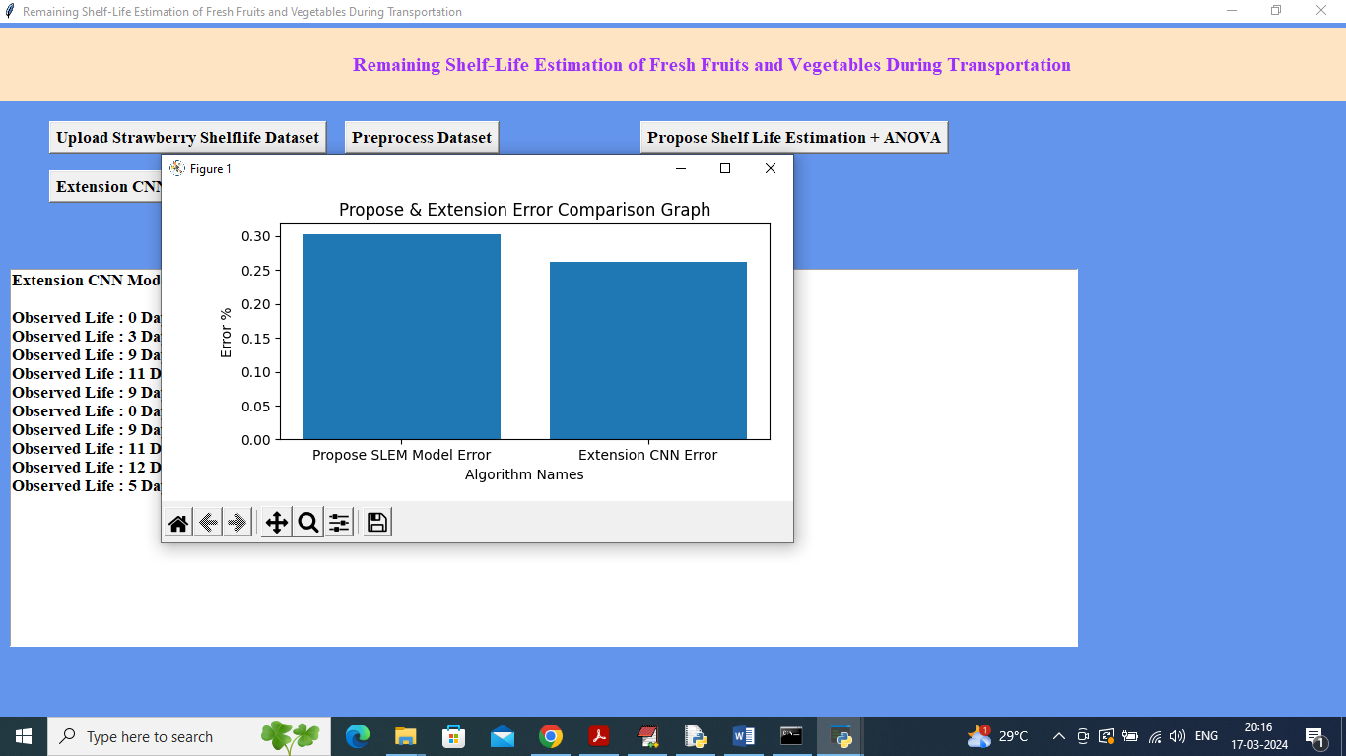

In above screen can see comparison between propose and extension algorithm where x-axis represents algorithm names and y-axis represents model error and in both algorithms extension got less error compare to propose ANOVA SLEM algorithm. Similarly you can upload and test other algorithms.

In below black console we can see ANOVA tables details

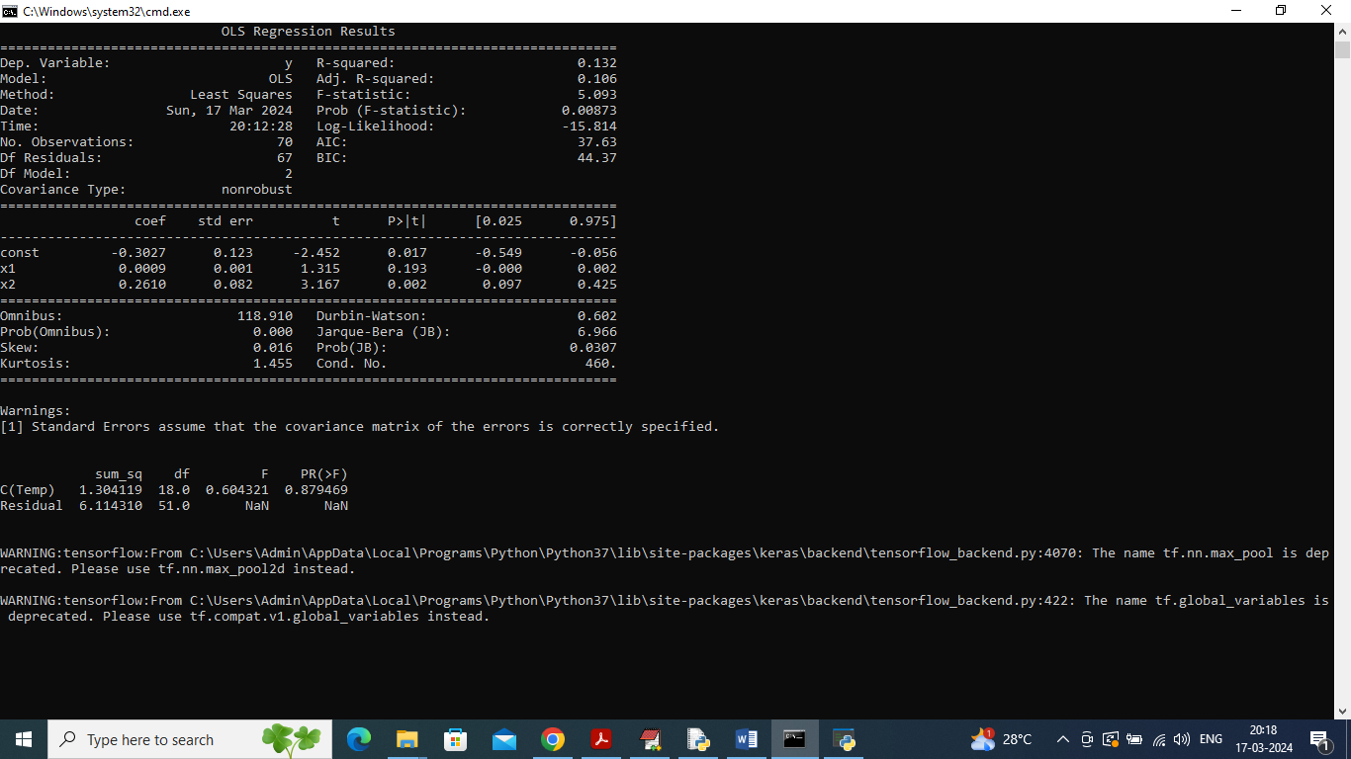

In above screen we can see ANOVA model summary which contains R2 square error and other metrics.